CSA1708-ARTIFICIAL INTELLIGENCE
LAB EXPERIMENTS
Program 9 : Python Program to Implement Travelling Salesman Problem
Aim
To develop a Python program to solve the Travelling Salesman Problem (TSP) using brute-force permutations to find the minimum cost Hamiltonian cycle visiting every city once and returning to the start city.
Algorithm
1. Represent the set of cities and pairwise distances between them using an N×N distance matrix.
2. Select a designated starting city (e.g., City 0) to avoid redundant cyclic permutations.
3. Identify the remaining (N - 1) cities that need to be visited.
4. Initialize the minimum travel cost to infinity and an empty optimal route list.
5. Generate all permutations of the remaining cities using itertools.permutations.
6. For each permutation:
7. a. Construct the complete tour path: Start City -> Permuted Cities -> Start City.
8. b. Compute the total cost of the tour by summing the distances between consecutive cities in the path.
9. c. If the computed tour cost is strictly less than the current minimum cost, update the minimum cost and store the current tour as the optimal route.
10. Display the optimal tour route and the minimum total travel cost.

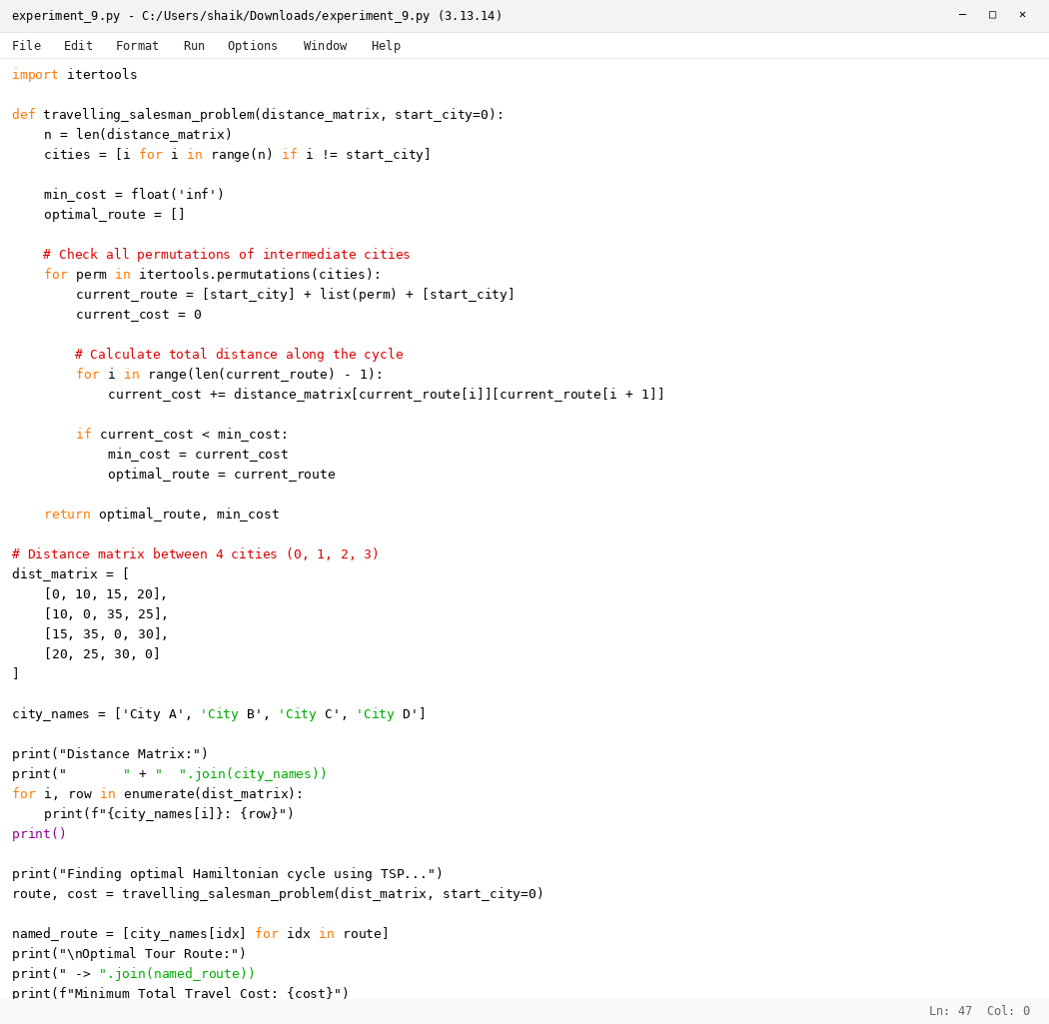

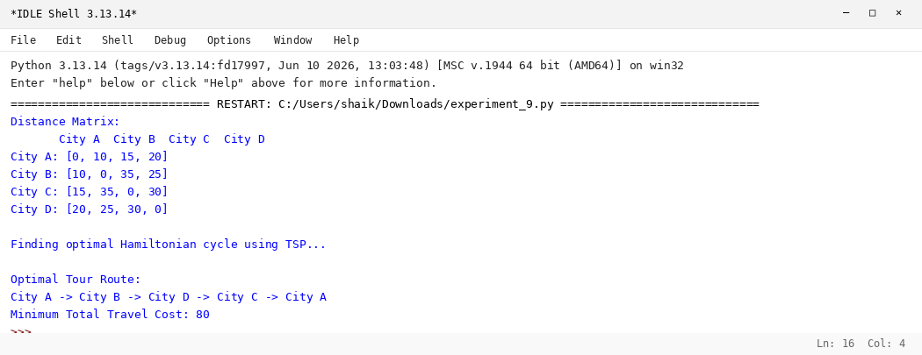

RESULT
Thus, the Travelling Salesman Problem was implemented successfully using Python.

